Lukass Kellijs handout

# Mechanics

- instant center of rotation - the point fixed to a body undergoing planar movement that has **zero velocity** at a particular instant of time. At this instant, the velocity vectors of the other points in the body generate a circular field around this point which is identical to what is generated by a pure rotation.

This approach can also be very useful in determining frictional forces (i.e. finding symmetric circles upon which, when rotating about the ICOR the frictional forces cancel each other).

**Lagrangian Formalism – generalised coordinate approach**

Let us call a generalised coordinate if the entire state of a system can be described by this single number.

Say we need to find the acceleration of coordinate . If we can express the potential energy of the system as a function of and the kinetic energy in the form where coefficient M is a combination of masses of the bodies (and perhaps of moments of inertia), then

This generalised coordinate can be used in many ways along with different other powerful techniques, for example:

**The components of a net force** can be determined by finding the change of the location of the centre of mass of the system with respect to the generalised coordinate . By differentiating this via time, we get the acceleration of the centre of mass in each axis in terms of the acceleration of the generalised coordinate, and thus we can determine the components of the net force and hence its magnitude. (See Kalda handout pr 32.)

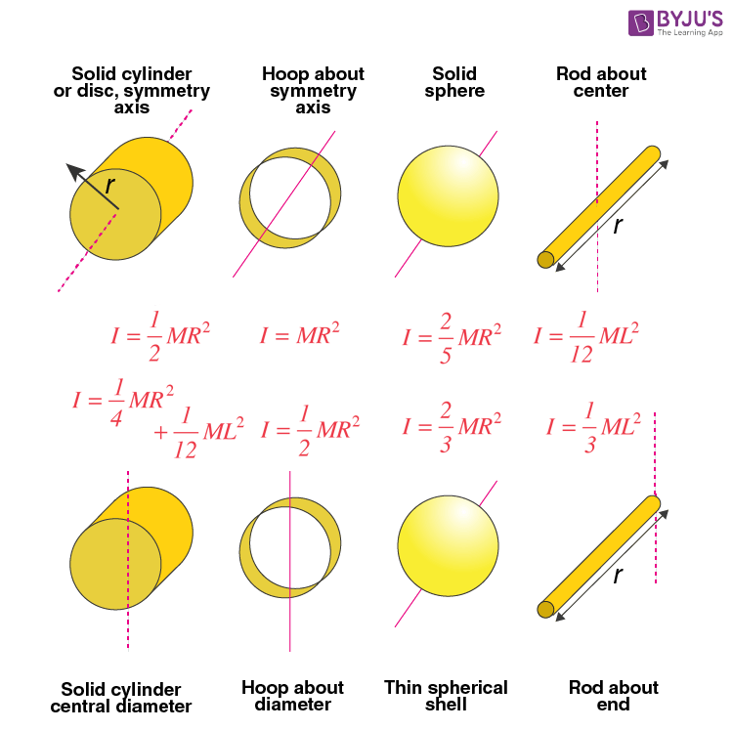**Moments of inertia**

The thin spherical shell formula can be used to derive the moment of inertia of a non-uniform density sphere.

Moment of inertia contains important information about the geometry of the system and can even be used in reverse to find this geometry.

Moment of inertia with respect to the center of mass can be found also using considerations of the dynamics of the system:

, where L – angular momentum and Ek – is kinetic energy with respect to the center of mass **of a rigid body**. This equation is obtained through the analogy of linear and angular momentum, where the total kinetic energy is related with the total momentum. And it is useful in the CM refference frame because there Ek and L are conserved. (See pr. 1. EuPhO 2018)

# Orbītas, Keplera likumi

Pamata sakarības var iegūt sākot ar *Uniform Circular Motion* formulām pielīdzinot centrtieces spēku gravitācijas spēkam iegūstot:

(speciālgadījums *Circular Orbits* – nav vispārīgi spēkā)

No kā izriet, ka

**Vispārīgo orbītu sakarības** ir ļoti līdzīgas, taču R aizvieto ar a – *semi-major axis length:*

Enerģija tiek saglabāta:

*Angular momentum* is conserved*:*

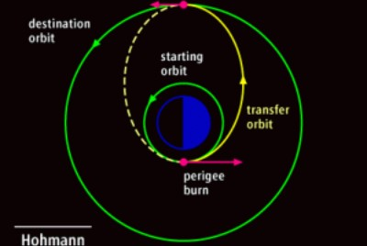Varam secināt, ka mainās orbītas laikā, kā arī mainās orbītas laikā. Jāatceras arī, ka kādā punktā var iegūt, izmantojot enerģijas vienādojumu, pielīdzinot kopējo enerģiju 0.

**Orbītu maiņas:**

Visbiežāk sastopamās orbītu maiņas redzamas iepriekšējā attēlā. Lai atrastu ātrumu kādu jāpiešķir objektam, lai tas mainītu orbītu ja šis objekts atrodas uz Zemes:

1. Aprēķini (pēc enerģijas saglabāšanās orbītas laikā un, zinot orbītas parametrus, kā piemēram lielās pusass garumu - a) kādu ātrumu nepieciešams iegūt, lai pārvietotos attiecīgajā orbītā
2. Aprēķini kāds šis ātrums ir attiecībā pret Zemes ātrumu.
3. Aprēķini (pēc enerģijas) kāds ātrums jāpiešķir objektam, lai sasniegtu šo ātrumu **un pārvarētu Zemes gravitācijas ietekmi**.

**NB** Ļoti bieži pieļauta kļūda šādos uzdevumos ir lielās pusass definīcijas sajaukšana – tā ir **puse** no attāluma starp elipses vistālākajiem punktiem.

# Electric Circuits:

**Termini:**

*Current source -* a component whose job is to provide a constant amount of current, outputting as much or as little voltage necessary to maintain that constant current.

# Ideālās gazes

Pamata noderīgie vienādojumi:

The *equipartition of energy* theorem states that every degree of freedom of a molecule has an energy per molecule. ( per mole), since: (thus is the constant for individual molecules, but is the constant for moles of a substance.)

If f is the number of degrees of freedom then the internal energy of a gas is:

And from this we can derive the molar specific heat (siltuma daudzums, ko viens mols vielas uzņem vai atdod, sasilstot vai atdziestot par 1 K grādu) of a gas at constant volume or constant pressure:

Also:

Also from the *equipartition of energy* theorem since translational motion has 3 degrees of freedom the average translational kinetic energy per molecule of an ideal gas is:

We can derive the formula for the root mean square speed from this:

, where – the molar mass

# Ideal gas Law:

Work of gas:

* This means that, when given a graph of the ideal gas you can obtain the work done in a particular instance as the area under the curve. The total work done by the gas during a closed loop process is the area enclosed by the process’ curve.

More important considerations about internal energy of a gas:

And if two containers of the same gas have the same temperature and amount of molecules, their internal energies are equal since

# Uzdevumi par lietderības koeficientu, vai pievadīto siltumu:

Galvenā lieta, ko šajos uzdevumos atcerēties ir, ka **pievadītais** siltums NAV vienāds ar gāzes padarīto darbu closed loop procesos. Kopējais siltums closed loop procesā ir **pievadītais – aizvadītais** siltums.

# Maiņstrāva, komplekso skaitļu metode

Maiņstrāvas spriegumu var aprakstīt ar kompleksu skaitli. . Līdzīgi arī strāvu un impedances Z var aprakstīt ar kompleksiem skaitļiem. Šajā gadījumā šie kompleksie skaitļi būtībā ir rotējoši vektori (skat. *phasors*).

Šādi darot, visus slēgumus var aprakstīt, izmantojot potenciālus un impedances:

un izmantot visas pastāvošās sakarības, kas ir spēkā rezistoriem virknes slēgumā.

Vispārīgs plāns:

1. Aprakstām spriegumu ar kompleksu skaitli
2. Aprakstām I ar kompleksu skaitli
3. Izveidojam sakarības pēc slēguma potenciāliem
4. Aprakstām slēgumu ar impedancēm
5. Atkarībā no prasībām ievietojam sakarībās vērtības, kompleksos skaitļus, izsakām
6. Atkarībā no prasībām pārejam uz reālo daļu

# Diferenciālvienādojumi

Vienmēr atrisinājums ir formā:

Attiecīgi var izmantot šo formu, lai izteiktu meklēto funkciju (pielīdzinātu) un iegūtu sakarības. Tādejādi iegūstot vispārīgo atrisinājumu. Ja atrisinājumi ir vairāki, tad var tos saskaitīt, lai paplašinātu “brīvības pakāpes” un tad šīs funkcijas koeficientus pielāgot atkarībā no sākuma stāvokļiem, izmantojot informāciju par funkciju un tās atvasinājumiem.

# Optics

Ņūtona formula:

# Electromagnetism

**Method of images**

Boundary value problems or problems involving boundaries can often be solved by the method of images.

<https://en.wikipedia.org/wiki/Method_of_images#:~:text=The%20method%20of%20images%20(or,respect%20to%20a%20symmetry%20hyperplane>.

It can be used in electrostatics to simply calculate or visualize the distribution of the electric field of a charge in the vicinity of a conducting surface (see Izlases kursi), or

It can be used Magnet-superconductor systems (see pr. 3. EuPhO 2017)

Or to model different flows or reflections at a boundary.

**Magnetic monopole method for magnetic dipoles**

When working with magnetic dipoles we can model their interaction with other objects (including other dipoles for that matter) by using magnetic monopoles.

A magnetic dipole can be modelled as a pair of magnetic monopoles of strength qm and −qm separated by a distance d such that = qmd.

Then we can use Maxwell’s Law’s for electric monopoles (charges) analogously on magnetic monopoles, including Gauss’ Law (thus by using the binomial expansion deriving the magnetic field a distance x>>d away from the dipole) and also use that the force is −qmB(x) + qmB(x + d).

# Approximations

**Taylor Series**

# Geometry for physics

**Parabola**

**Definition:** A parabola is a curve where any point is at an equal distance from ***the focus*** of the parabola and a fixed straight line (***the directrix***).

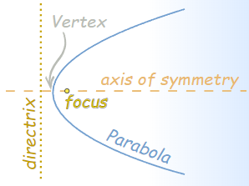***The vertex*** is halfway between the focus and directrix.

**Reflection:** Any ray parallel to the axis of symmetry gets reflected off the parabola straight to the focus.

Consequently the angle between the parallel ray and the tangent to the parabola at a point P, is equal to the angle between a line connecting the point P, and the tangent of the parabola at point P. (see fig. above)

**Sketchy property from EuPhO 2019:** for any point on a parabola, its distance from the focus plus its distance from a horizontal line is constant.

**Ellipses**